**HTML @ codecademy**

* Every webpage you look at is written in a language called HTML
* HTML stands for **HyperText Markup Language**.
* **Hypertext** means "text with links in it
* A **markup language** is a programming language used to make text do more than just sit on a page: it can turn text into images, links, tables, lists, and much more
* What makes webpages pretty? That's CSS—**Cascading Style Sheets**. Think of it like skin and makeup that covers the bones of HTML
* 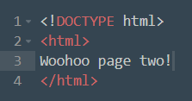
* Things inside <>s are called **tags**.
* Tags nearly always come in pairs: an opening tag and a closing tag
* <https://www.codecademy.com/articles/glossary-html>
* Placing one HTML tag inside of another is called **nesting**.
* **Link**: <a href=”url address”>name your link</a>
* **Image:** <img src=”image irl address” />
* **Ordered list:** 
  + <ol>
    - <li></li>
  + </ol>
* **Unordered list**: <ul>
* **<!-- comment -->**
* 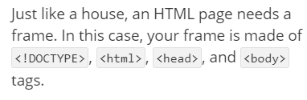
* 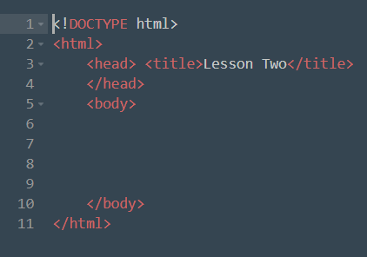
* The title goes in the head, the head*er*(s) go in the body!
* 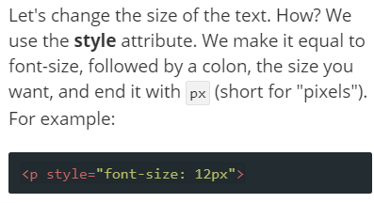
* Color <https://www.w3.org/TR/css-color-3/#svg-color>
* Font-family <http://www.w3.org/TR/CSS21/fonts.html#generic-font-families>
* Font-size 10px
* Background-color
* 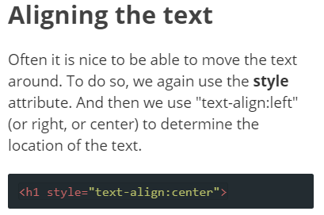
* <strong>**bold**</strong>
* <em>*italics*</em> (i.e. *em*phasize)
* 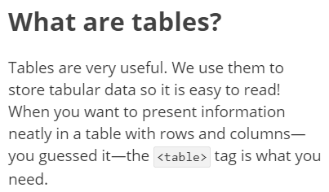
* 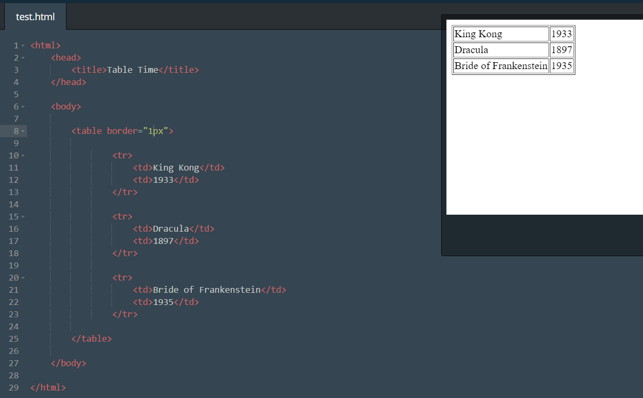
* Div
* Span

**CSS @ codecademy**

* CSS (which stands for **C**ascading **S**tyle **S**heets) is a language used to describe the appearance and formatting of your HTML.
* A **style sheet** is a file that describes how an HTML file should look. That's it!
* 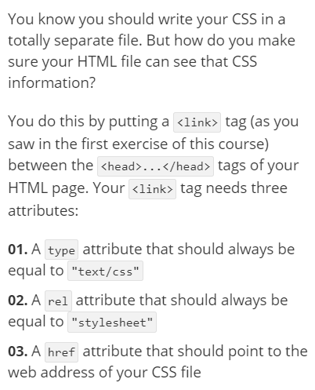
* 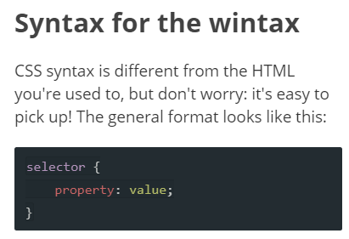
* 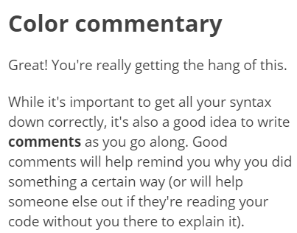
* 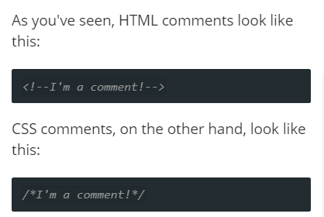
* [**https://www.google.co.nz/search?q=hex+color+picker&rlz=1C1GGRV_enNZ790NZ790&oq=hex+colo&aqs=chrome.3.69i57j0l5.5213j0j9&sourceid=chrome&ie=UTF-8**](https://www.google.co.nz/search?q=hex+color+picker&rlz=1C1GGRV_enNZ790NZ790&oq=hex+colo&aqs=chrome.3.69i57j0l5.5213j0j9&sourceid=chrome&ie=UTF-8)
* 
 